Task 2: System requirements

The functional requirements would be as follows:

* Sign-up screen: When users are using the app for the first time, they will be required to create a password and username. The password and username will be stored in a database with a unique number associated to it.
* Login-Screen: Users will be required to log into the app by entering a username and password. The app will try to match the username and password entered those stored in the database to confirm login
* Main Menu: Displays options for creating a new virtual room, accessing existing rooms, browsing the furniture catalogue, making purchases and viewing previous transaction history.
* Virtual room creation: Users can sketch the floor plan using a 2D interface, including walls, doors and windows. They will also be able to transition to a 3D stage for visualizing the room. There is the ability to add, move, rotate and resize furniture items. Other options will also include the ability to modify colors, textures, and materials for walls, floors and furniture.
* Payment screen: This will process payments by requirement banking details such as a card banking number, card holder name etc.
* Transaction history. Confirmation of the order will be displayed with details such as Vendor, total cost, and the items bought. An estimation of when the items will be delivered will also be included in this sector.

**NON-FUNCTIONAL REQUREMENTS**SECURITY:  
Security is the most important requirement which will be on the first screen “login and creation screen” to provide safety and privacy to users. Password, password hint and verification will be required. When a user forgets his/her password he/she will be sent a code for verification or a password hint before logging in.   
  
USABILITY:  
It is guaranteed that users will be able to interact with the “Home Interior Design” App. The app will allow users to use the drag-and-drop interface to place furniture and objects where they want to place them, it will also have the rotate option to allow users to rotate objects be the way they want them to be and, in the angle, they want them to be. It will be easy for users to precisely define the proportions of walls, doors, windows, and rooms.  
  
PERFORMANCE:  
The app is designed to work perfectly in everything especially on the process speed. If a user picks a colour for a wall or a couch, it will change immediately to whatever colour the user wants. Also, the user is allowed to change the colour if he/she is not satisfied.

Screen Designs

Login:

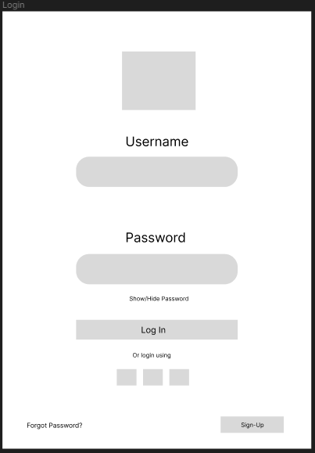

Sign-up:

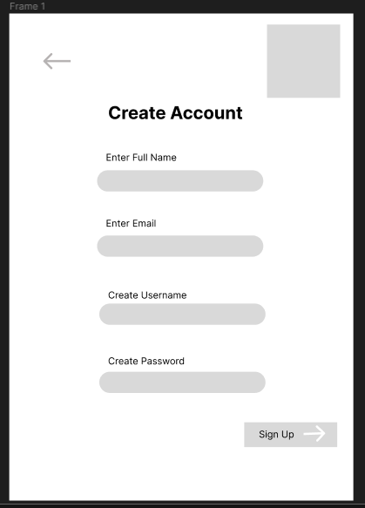

Main Menu:

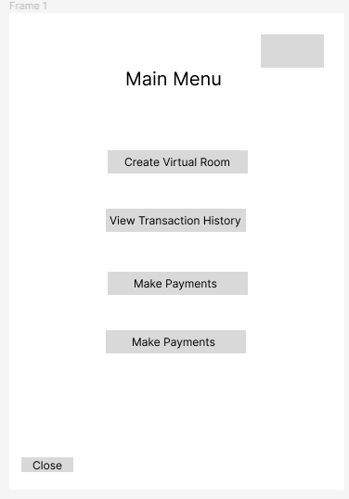

Virtual room creation:

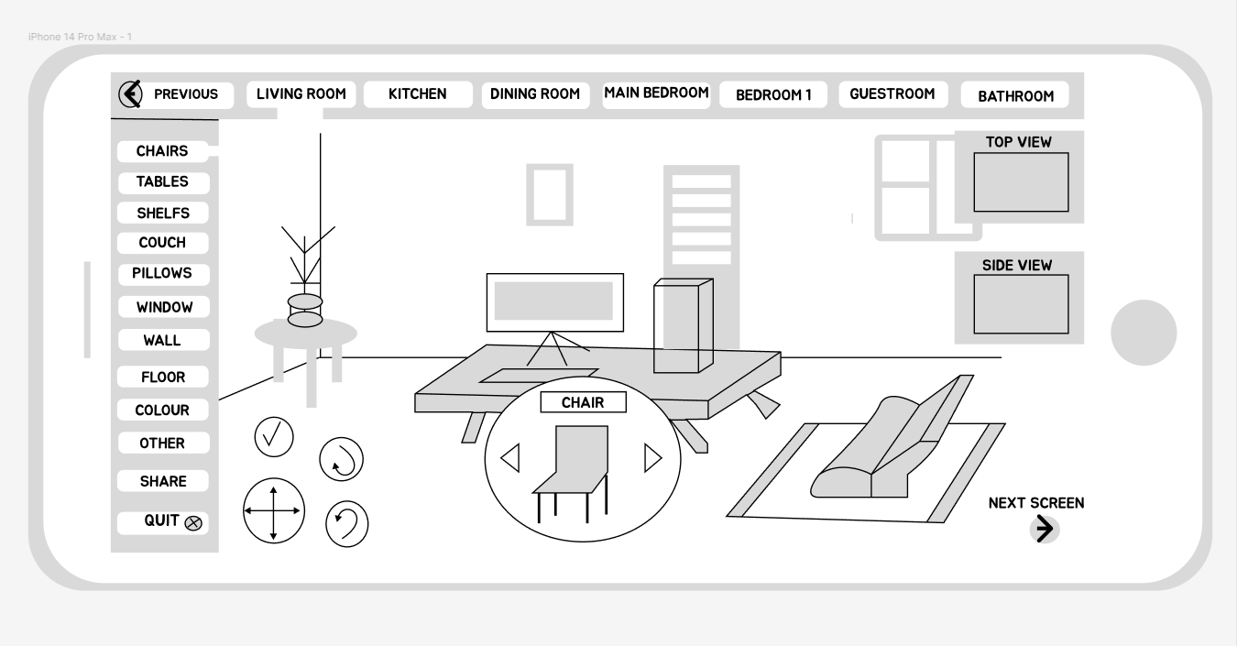

Payment:

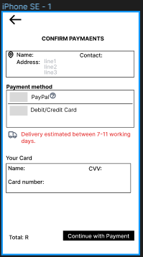

Transaction history:

